
Dashboard Design

Date | 26 July 2026
Team ID | MIRUTHALA M K
Project Name | Global AI Adoption in Education
Maximum Marks | 5 Marks

Activity 1: Interactive and Visually Appealing Dashboards
The core design principles—including a Clear and Intuitive Layout, Appropriate Color and Theming, Interactive Filters, and Effective Visual Presentation—have been applied to create the Global AI Adoption in Education Dashboard.
The dashboard combines multiple visualizations to provide a comprehensive view of AI adoption across countries, regions, educational user groups, communities, and AI tools.
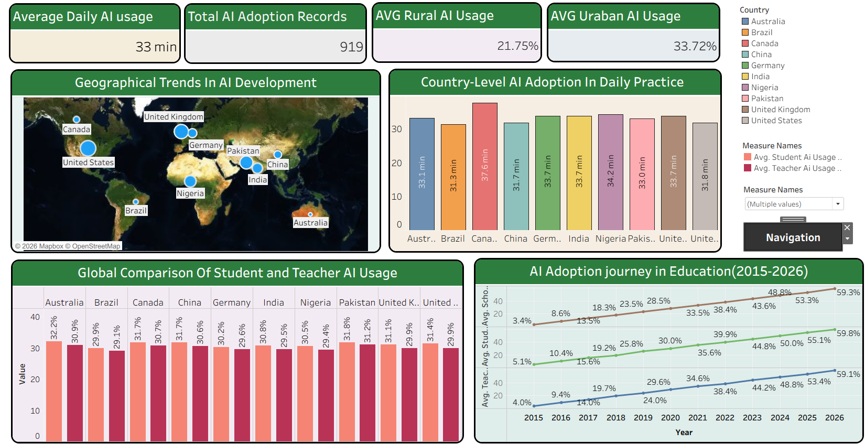

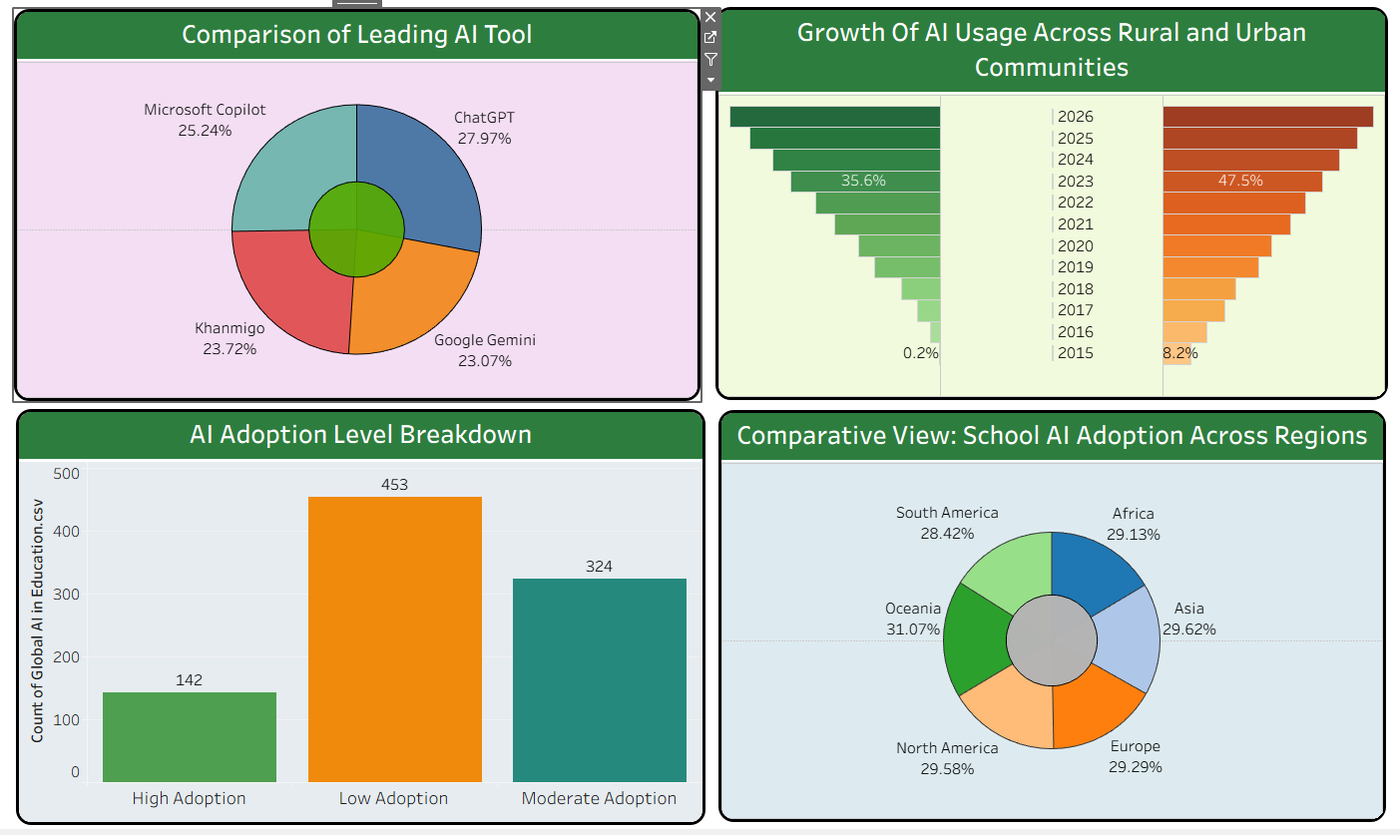

Key Outcomes and Insights
● Global AI Adoption Overview: The KPI cards provide a quick summary of the analysis, including 33 minutes of average daily AI usage, 919 total AI adoption records, 21.75% average rural AI usage, and 33.72% average urban AI usage.
● Country-Level AI Usage Comparison: The country comparison bar chart allows users to compare average daily AI usage across different countries. Canada shows the highest average daily AI usage among the displayed countries at approximately 37.6 minutes.
● Student and Teacher AI Usage Comparison: The grouped bar chart compares AI usage between students and teachers across different countries. The visualization shows that student AI usage is slightly higher than teacher AI usage in most countries.
● AI Adoption Growth Over Time: The trend visualization shows the growth of student AI usage, teacher AI usage, and school AI adoption from 2015 to 2026. School AI adoption increased from approximately 5.1% in 2015 to 59.8% in 2026, demonstrating significant growth in AI integration within education.
● Leading AI Tools: The AI tool market share visualization compares ChatGPT, Microsoft Copilot, Khanmigo, and Google Gemini. ChatGPT has the highest share at 27.97%, followed by Microsoft Copilot at 25.24%, Khanmigo at 23.72%, and Google Gemini at 23.07%.
● Rural-Urban AI Adoption Gap: The dashboard highlights a difference between rural and urban AI usage. The average rural AI usage is 21.75%, while urban AI usage is 33.72%, showing higher AI usage in urban communities.
● AI Adoption Level Distribution: The adoption-level chart categorizes records into High, Moderate, and Low adoption. Low Adoption contains 453 records, Moderate Adoption contains 324 records, and High Adoption contains 142 records.
● Regional School AI Adoption: The regional comparison chart shows differences in school AI adoption across regions. Oceania has the highest school AI adoption at 31.07%, while South America has the lowest among the displayed regions at 28.42%.
● Interactive Data Exploration: The Tableau dashboard enables users to explore different aspects of AI adoption through interactive visualizations and filters, allowing users to compare countries, years, regions, AI tools, and adoption categories.

Activity 2: Live Deployment Link
Below is the verified public access link to the interactive, cloud-hosted visualization story:
Tableau Public Dashboard Link:
https://public.tableau.com/app/profile/miruthala.m.k/viz/GlobalAIinEducationDashboard-1/Dashboard1?publish=yes
https://public.tableau.com/app/profile/miruthala.m.k/viz/GlobalAIinEducationDashboard-2/Dashboard2?publish=yes

